**EV VECHILE SALES BY INCOME AND VECHILE TYPE**

**REPORT ON MARKET SEGMENTATION FOR 2ND PROJECT**

**BY**

**K UDAY**

**REQUIREMENTS**

**1. Introduction**

This analysis report explores the dataset on vehicle sales across various states, aiming to understand the distribution of total sales by vehicle type, segment the top vehicle type by state, assess statewise sales, and analyze electric vehicle (EV) sales. The analysis uses Python libraries such as Pandas, Matplotlib, and Seaborn for data manipulation and visualization.

**2. Data Loading and Setup**

Importing Libraries and File Upload  
The required libraries were imported, including Pandas for data handling, Matplotlib and Seaborn for visualization, and Google Colab Files for file upload. Error handling was applied to ensure smooth uploading and reading of the file. The data was successfully loaded into a DataFrame named df.

**3. Initial Data Analysis**

Dataset Overview and Summary  
After loading, the dataset’s first few rows (df.head()) were displayed, providing insight into the structure and confirming the expected columns. Summary statistics (df.describe()) were generated for all numerical columns, helping to understand data characteristics such as mean values, standard deviation, and range. These statistics are essential for spotting any anomalies, extreme values, or trends in the numerical data.

**4. Total Sales by Vehicle Type**

A bar chart was created to show total sales for each vehicle type across all states:

* **Objective**: Determine the overall popularity and sales volume of different vehicle types.
* **Result**: Two-wheelers, four-wheelers, and goods vehicles were among the highest-selling categories, as illustrated by their total sales on the bar chart.

**5. Top Vehicle Type by State**

To understand the most popular vehicle type in each state:

* **Method**: Identified the vehicle type with the highest sales in each state using the .idxmax() function, and a new column was added to df indicating the top vehicle type and its sales per state.
* **Visualization**: A bar plot of the frequency of top vehicle types across states was created. This plot highlights which vehicle types lead in most states.
* **Result**: Four-wheelers and two-wheelers were dominant as the top vehicle types in many states, indicating their broad demand across regions.

**6. State wise Vehicle Sales**

**Purpose**: To visualize the distribution of vehicle sales by state and vehicle type.

* **Method**: Grouped data by state and calculated total sales for each vehicle type. A heatmap was used to visually compare sales across states and vehicle types.
* **Result**: The heatmap showed states with higher sales volumes and highlighted specific vehicle types with higher demand in certain areas.

**7. Electric Vehicle (EV) Sales Analysis**

This analysis focused on total EV sales by state:

* **Calculation**: A new column calculated total EV sales across vehicle types for each state. EV sales were then summed across states.
* **State Comparisons**: Identified states with the highest and lowest EV sales.
* **Visualization**: A bar chart illustrated EV sales by state, making it easy to identify states leading or lagging in EV adoption.
* **Result**: The analysis highlighted which states were early adopters of EVs and which might need further promotion or incentives to encourage EV usage.

**8. Conclusion** This report presents a thorough breakdown of vehicle sales across states, emphasizing popular vehicle types and EV adoption. The analysis provides valuable insights into vehicle sales trends, particularly around high-demand categories and EV adoption patterns.

**CODE :**

# Step 1: Import necessary libraries

import pandas as pd

import matplotlib.pyplot as plt

import seaborn as sns

from google.colab import files

# Step 2: Upload your dataset with error handling

try:

    uploaded = files.upload()  # This will prompt you to upload the CSV file

    file_name = list(uploaded.keys())[0]  # Get the name of the uploaded file

except Exception as e:

    print("Error uploading file:", e)

# Step 3: Load the dataset into a pandas DataFrame with error checking

try:

    df = pd.read_csv(file_name)  # Load the uploaded file

except Exception as e:

    print("Error loading the dataset:", e)

# Step 4: Perform basic data analysis

print("Dataset Overview:")

print(df.head())           # Display first few rows of the dataset

print("\nData Summary:")

print(df.describe())       # Summary statistics

# Step 5: Visualize the data - Total Sales by Vehicle Type

# Calculate total sales per vehicle type across all states

vehicle_totals = df[['Two Wheeler', 'Three Wheeler', 'Four Wheeler', 'Goods Vehicles',

                     'Public Service Vehicle', 'Special Category Vehicles',

                     'Ambulance/Hearses', 'Construction Equipment Vehicle', 'Other']].sum()

# Plot total sales by vehicle type

plt.figure(figsize=(10, 6))

vehicle_totals.plot(kind='bar', color='skyblue', edgecolor='black')

plt.title("Total Sales by Vehicle Type Across All States")

plt.ylabel("Total Sales")

plt.xlabel("Vehicle Type")

plt.xticks(rotation=45)

plt.show()

# Step 6: Data Segmentation - Top Vehicle Type by State

# Identify the top-selling vehicle type in each state

df['Top Vehicle Type'] = df[['Two Wheeler', 'Three Wheeler', 'Four Wheeler',

                             'Goods Vehicles', 'Public Service Vehicle',

                             'Special Category Vehicles', 'Ambulance/Hearses',

                             'Construction Equipment Vehicle', 'Other']].idxmax(axis=1)

df['Top Vehicle Sales'] = df[['Two Wheeler', 'Three Wheeler', 'Four Wheeler',

                              'Goods Vehicles', 'Public Service Vehicle',

                              'Special Category Vehicles', 'Ambulance/Hearses',

                              'Construction Equipment Vehicle', 'Other']].max(axis=1)

print("\nTop Selling Vehicle Type by State:")

print(df[['State Name', 'Top Vehicle Type', 'Top Vehicle Sales']])

# Visualize frequency of top vehicle types across states

top_vehicle_counts = df['Top Vehicle Type'].value_counts()

plt.figure(figsize=(10, 6))

sns.barplot(x=top_vehicle_counts.index, y=top_vehicle_counts.values, palette="viridis")

plt.title("Frequency of Top-Selling Vehicle Type by State")

plt.xlabel("Vehicle Type")

plt.ylabel("Number of States where Vehicle Type is Top-Selling")

plt.xticks(rotation=45)

plt.show()

# Step 7: Data Segmentation - Statewise Vehicle Sales

# Group data by state and calculate total sales for each vehicle type

statewise_totals = df.groupby('State Name')[vehicle_totals.index].sum()

print("\nSales by State and Vehicle Type:")

print(statewise_totals.head())

# Optional: Heatmap of sales by state and vehicle type

plt.figure(figsize=(12, 8))

sns.heatmap(statewise_totals, annot=True, fmt=".0f", cmap="YlGnBu", cbar=True)

plt.title("Vehicle Sales by State and Type")

plt.xlabel("Vehicle Type")

plt.ylabel("State Name")

plt.xticks(rotation=45)

plt.show()

# Step 8: Analyze Electric Vehicle (EV) Sales

# Calculate total EV sales per state

# Replace 'Electric Vehicle' with the actual column names in your dataset if needed

df['Total EV Sales'] = df[['Two Wheeler', 'Three Wheeler', 'Four Wheeler', 'Goods Vehicles',

                            'Public Service Vehicle', 'Special Category Vehicles',

                            'Ambulance/Hearses', 'Construction Equipment Vehicle',

                            'Other']].sum(axis=1)  # Update with correct EV column names

# Identify the total EV sales for each state

ev_sales_by_state = df.groupby('State Name')['Total EV Sales'].sum()

# Find the state with the maximum and minimum EV sales

max_ev_state = ev_sales_by_state.idxmax()

max_ev_sales = ev_sales_by_state.max()

min_ev_state = ev_sales_by_state.idxmin()

min_ev_sales = ev_sales_by_state.min()

print("\nState with Most EV Sales:")

print(f"{max_ev_state} with {max_ev_sales} EV sales")

print("\nState with Least EV Sales:")

print(f"{min_ev_state} with {min_ev_sales} EV sales")

# Visualize EV sales by state

plt.figure(figsize=(12, 6))

ev_sales_by_state.plot(kind='bar', color='lightgreen', edgecolor='black')

plt.title("Total EV Sales by State")

plt.ylabel("Total EV Sales")

plt.xlabel("State Name")

plt.xticks(rotation=45)

plt.show()

Dataset Overview:

State Name Two Wheeler Three Wheeler Four Wheeler \

0 Andaman and Nicobar Island 1 30.0 81

1 Arunachal Pradesh 14 NaN 5

2 Assam 721 47041.0 161

3 Bihar 5003 59079.0 114

4 Chandigarh 298 1410.0 182

Goods Vehicles Public Service Vehicle Special Category Vehicles \

0 NaN 40.0 NaN

1 NaN NaN NaN

2 7.0 15.0 NaN

3 11.0 26.0 NaN

4 NaN 40.0 NaN

Ambulance/Hearses Construction Equipment Vehicle Other Grand Total

0 NaN NaN 7.0 159

1 NaN NaN 1.0 20

2 NaN NaN 2.0 47947

3 NaN NaN 8.0 64241

4 NaN NaN 1.0 1931

Data Summary:

Two Wheeler Three Wheeler Four Wheeler Goods Vehicles \

count 37.000000 33.000000 37.000000 33.00000

mean 15272.540541 39223.393939 1423.513514 184.00000

std 47344.753528 119445.380804 4490.134399 585.02564

min 0.000000 0.000000 0.000000 0.00000

25% 16.000000 32.000000 10.000000 2.00000

50% 1417.000000 2115.000000 121.000000 11.00000

75% 10299.000000 18595.000000 615.000000 35.00000

max 282542.000000 647186.000000 26335.000000 3036.00000

Public Service Vehicle Special Category Vehicles Ambulance/Hearses \

count 29.000000 14.000000 10.000000

mean 140.620690 58.571429 1.200000

std 401.896256 135.808527 1.813529

min 0.000000 0.000000 0.000000

25% 2.000000 0.250000 0.000000

50% 23.000000 2.000000 1.000000

75% 43.000000 20.500000 1.000000

max 2039.000000 410.000000 6.000000

Construction Equipment Vehicle Other Grand Total

count 10.000000 33.000000 37.000000

mean 79.400000 267.393939 52235.837838

std 160.093167 831.477711 162721.633466

min 0.000000 0.000000 0.000000

25% 0.000000 1.000000 277.000000

50% 1.000000 13.000000 7593.000000

75% 19.750000 61.000000 44291.000000

max 397.000000 4412.000000 966363.000000

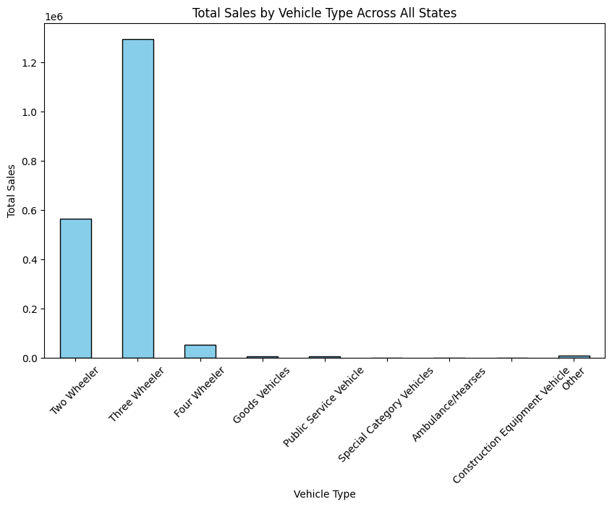

Top Selling Vehicle Type by State:

State Name Top Vehicle Type \

0 Andaman and Nicobar Island Four Wheeler

1 Arunachal Pradesh Two Wheeler

2 Assam Three Wheeler

3 Bihar Three Wheeler

4 Chandigarh Three Wheeler

5 Chhattisgarh Two Wheeler

6 Delhi Three Wheeler

7 Goa Two Wheeler

8 Gujarat Two Wheeler

9 Haryana Three Wheeler

10 Himachal Pradesh Two Wheeler

11 Jammu and Kashmir Two Wheeler

12 Jharkhand Three Wheeler

13 Karnataka Two Wheeler

14 Kerala Two Wheeler

15 Ladakh Four Wheeler

16 Maharashtra Two Wheeler

17 Manipur Three Wheeler

18 Meghalaya Two Wheeler

19 Mizoram Two Wheeler

20 Nagaland Four Wheeler

21 Odisha Two Wheeler

22 Puducherry Two Wheeler

23 Punjab Two Wheeler

24 Rajasthan Three Wheeler

25 Sikkim Four Wheeler

26 Tamil Nadu Two Wheeler

27 Tripura Three Wheeler

28 Dadra and Nagar Haveli and Daman and Diu Four Wheeler

29 Uttar Pradesh Three Wheeler

30 Uttarakhand Three Wheeler

31 West Bengal Three Wheeler

32 Grand Total Three Wheeler

33 Andhra Pradesh Two Wheeler

34 Madhya Pradesh Two Wheeler

35 Telangana Two Wheeler

36 Lakshadweep Two Wheeler

Top Vehicle Sales

0 81.0

1 14.0

2 47041.0

3 59079.0

4 1410.0

5 6424.0

6 112831.0

7 1314.0

8 13662.0

9 18595.0

10 368.0

11 1417.0

12 8986.0

13 56737.0

14 10299.0

15 5484.0

16 51149.0

17 443.0

18 16.0

19 9.0

20 121.0

21 10329.0

22 1429.0

23 6408.0

24 29631.0

25 2414.0

26 44302.0

27 7510.0

28 153.0

29 257159.0

30 22096.0

31 40948.0

32 647186.0

33 0.0

34 0.0

35 0.0

36 0.0

<ipython-input-1-e1ed6e6c1a03>:60: FutureWarning:

Passing `palette` without assigning `hue` is deprecated and will be removed in v0.14.0. Assign the `x` variable to `hue` and set `legend=False` for the same effect.

sns.barplot(x=top_vehicle_counts.index, y=top_vehicle_counts.values, palette="viridis")

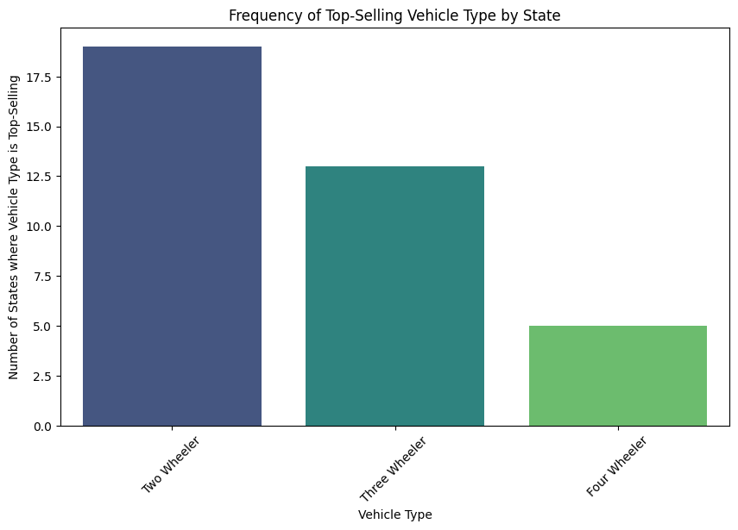

Sales by State and Vehicle Type:

Two Wheeler Three Wheeler Four Wheeler \

State Name

Andaman and Nicobar Island 1 30.0 81

Andhra Pradesh 0 0.0 0

Arunachal Pradesh 14 0.0 5

Assam 721 47041.0 161

Bihar 5003 59079.0 114

**Goods Vehicles Public Service Vehicle**

State Name

Andaman and Nicobar Island 0.0 40.0

Andhra Pradesh 0.0 0.0

Arunachal Pradesh 0.0 0.0

Assam 7.0 15.0

Bihar 11.0 26.0

Special Category Vehicles Ambulance/Hearses \

State Name

Andaman and Nicobar Island 0.0 0.0

Andhra Pradesh 0.0 0.0

Arunachal Pradesh 0.0 0.0

Assam 0.0 0.0

Bihar 0.0 0.0

Construction Equipment Vehicle Other

State Name

Andaman and Nicobar Island 0.0 7.0

Andhra Pradesh 0.0 0.0

Arunachal Pradesh 0.0 1.0

Assam 0.0 2.0

Bihar 0.0 8.0

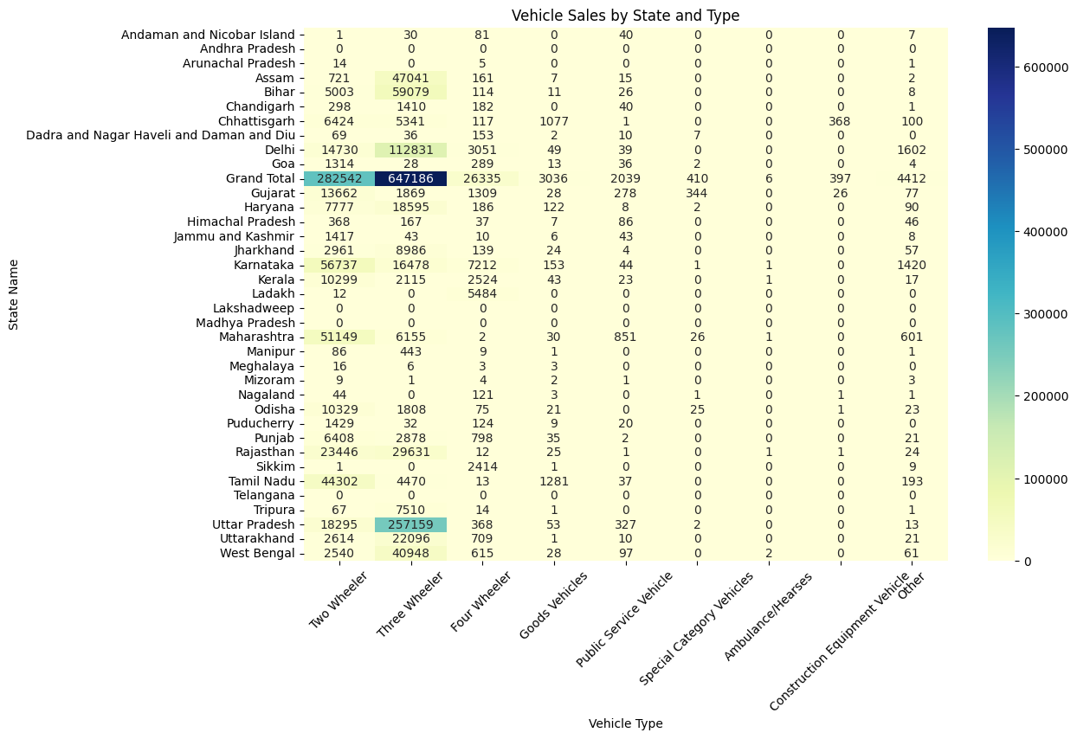

State with Most EV Sales:

Grand Total with 966363.0 EV sales

State with Least EV Sales:

